Brendan R O’Hara

Our Climate Florida Chapter

Remote and Hybrid Intern

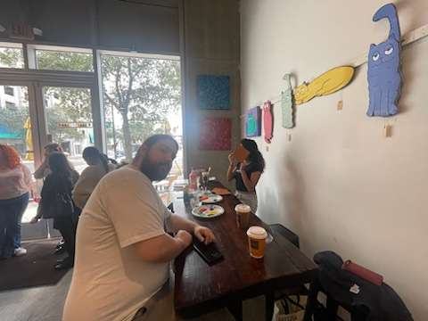

Brendan O’Hara painting up signs with Our Climate at Khava Coffee

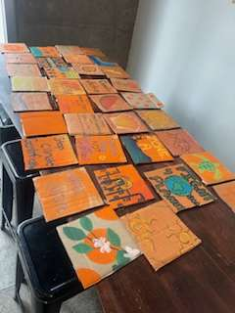

A sample of tiles meant to be used as an art piece displayed for legislators and activists

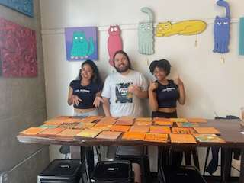

Three Our Climate Members, Asanette Ruiz, and Chavelle Zackery

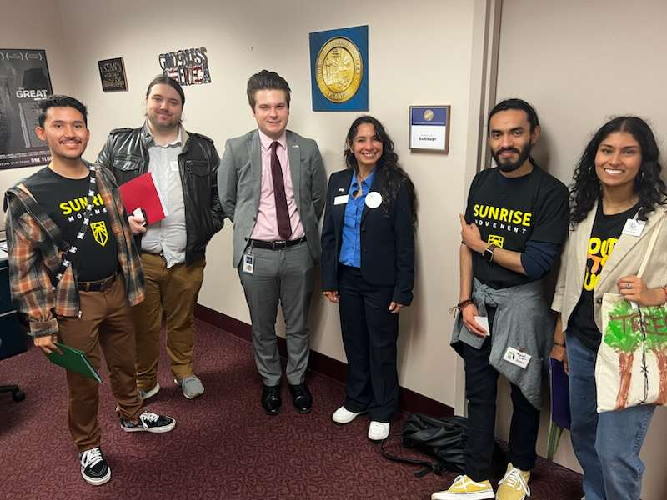

Assorted mix of Sunrise Movement and Our Climate along with Solemi Hernandez after meeting legislative aids.

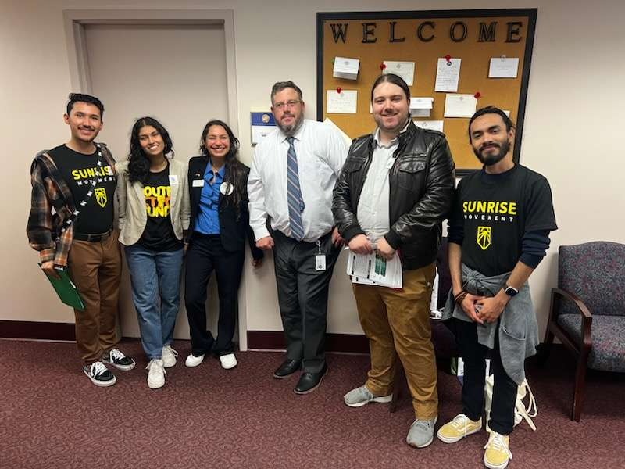



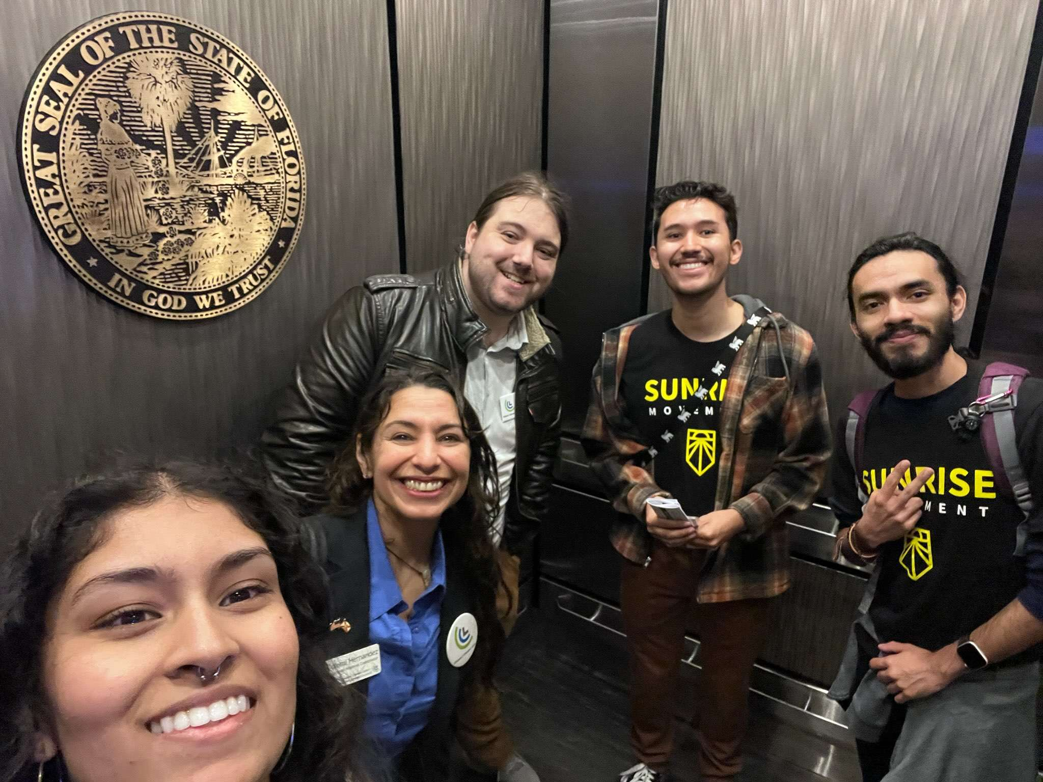

Activists in an elevator

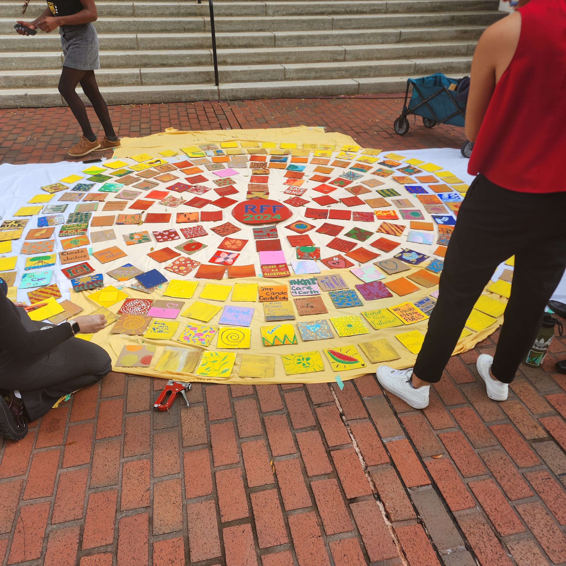

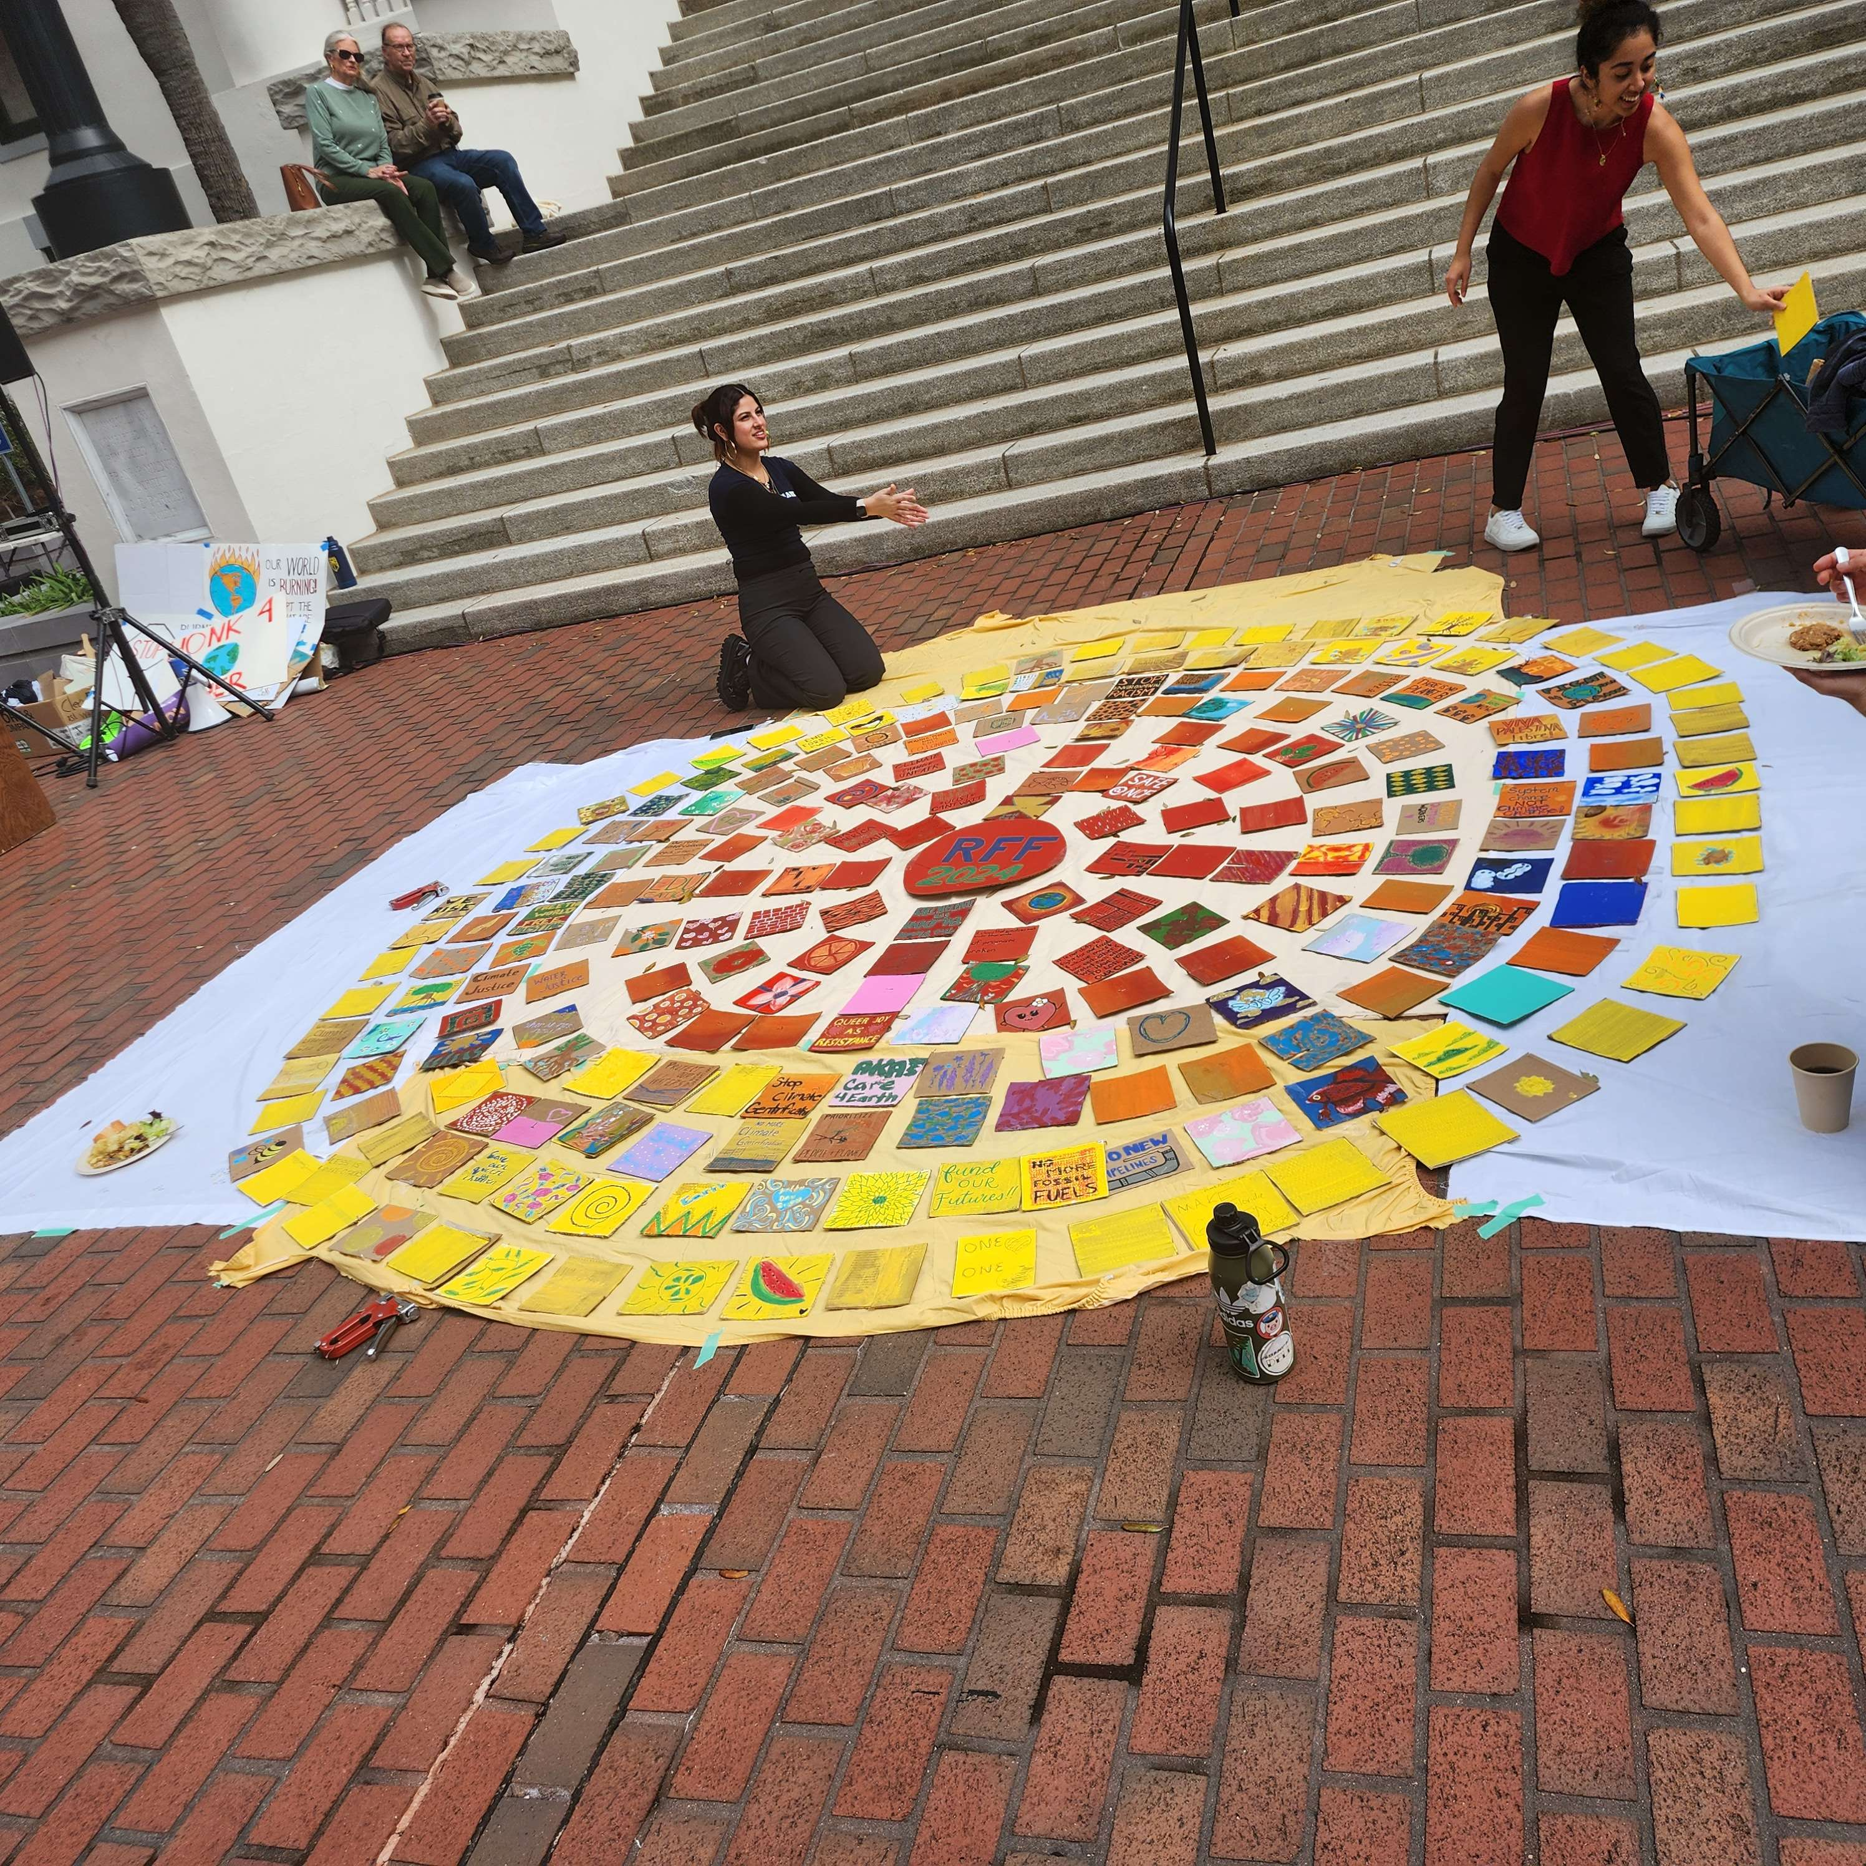

Art build of the sun, representing clean energy and the bright future of Florida

Team members stop during hike in Robinson Preserve

